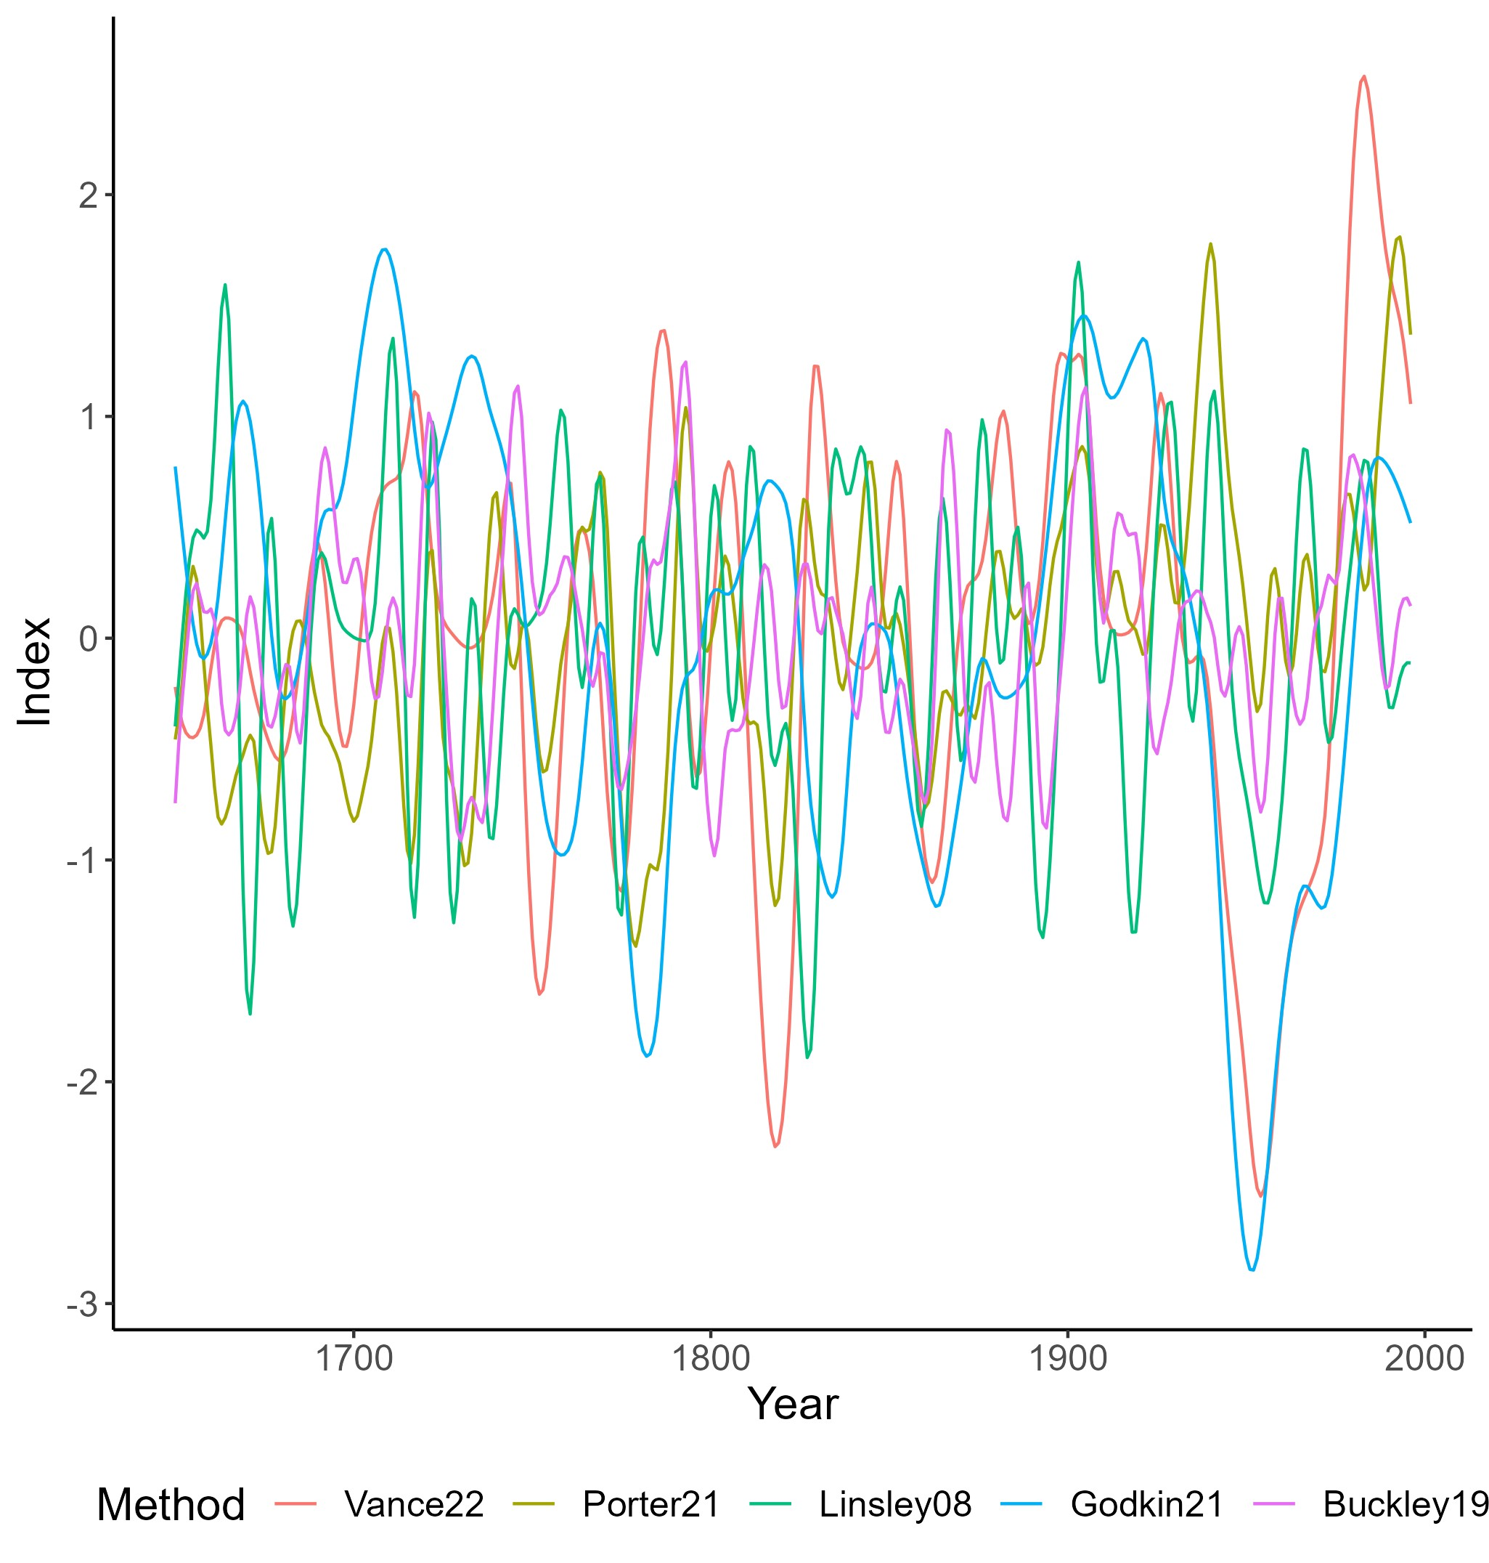

Figure 2. Reconstructions of IPO. Reconstructions truncated to common period of overlap (1650-1996) and scaled to mean 0, standard deviation 1 over this period. Displayed as 11-year spline fit for display purposes. Methods described in Linsley et al., 2008; Buckley et al., 2019; Godkin et al., 2021; Porter et al., 2021; Vance et al., 2022.